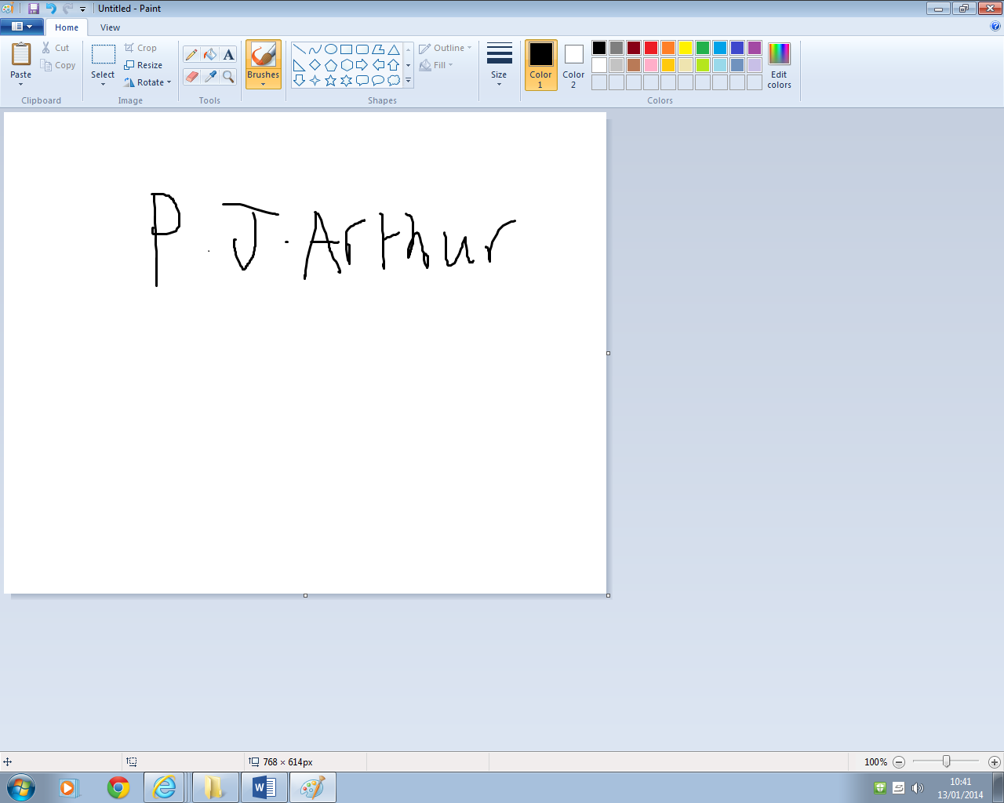**17 Willow Road St David’s SA62 4FR**

Yours faithfully

**P. J. Arthur**

Peter

Dear Miss Christine Shepard,

You have been invited as a V.I.P. for the car show in **The Dome, London** on the 17th July, as a thank you for your donations. During your visit, you will have special treatment; such as: Test driving the cars, goody bags, sham-pane and more.

**The Dome, London LN22 DTY**

**10th January 2014**

**Miss Christine Shepard 17 Willow Road St David’s SA62 4FR**